全国2009年1月高等教育自学考试
高级英语试题
课程代码：00600
请将答案填在答题纸相应位置上。全部题目用英文作答(英译汉题目除外)

I. The following paragraphs are taken from the textbooks, followed by a list of words or expressions marked A to X. Choose the one that best completes each of the sentences and write the corresponding letter on your Answer Sheet. One word or expression for each blank only. ( 12 points, 0.5 point for each )
Work therefore is desirable, first and foremost, as a 1 of boredom, for the boredom that a man feels when he is doing necessary though uninteresting work is as nothing in 2 with the boredom that he feels when he has nothing to do with his days. With this advantage of work another is 3 , namely that it makes holidays much more delicious 4 they come. Provided a man does not have to work so hard as to 5 his vigor, he is likely to find far more zest in his free time 6 an idle man could possibly find.
Discussing the question, some time 7 , with an old friend, she gave me her never-failing 8 for sleeplessness, which was to imagine 9 performing some trivial 10 over and over again, until, her mind becoming disgusted with the monotony of life, 11 drew the curtain. Her favourite device was to imagine a picture not 12 quite plumb upon the wall, and then to proceed to straighten it.
I believe that over a period of decades newspapers have become a 13 rather than a function. They have held their 14 so long that change has become 15 . I do not know, in fact, of any 16 that has changed as little in the last twenty years as the 17 press. And this resistance to change is the end of 18 —which, in turn, marks the end of usefulness.
The key is to segment the market 19 . This enables the company to pitch 20 customers with specialized 21 that no other company can begin to 22 . Example: One customer segment is the 23 profession. Cable & Wireless is developing features and functions that 24 tremendous appeal to lawyers.
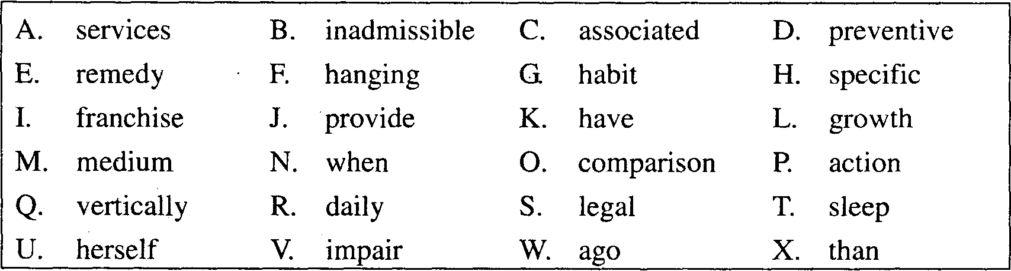
II. In this section, there are fifteen sentences taken from the textbooks with a blank in each, followed by a list of words or expressions marked A to X. Choose the one that best completes each of the sentences and write the corresponding letter on your Answer Sheet. One word or expression for each blank only. ( 15 points, 1 point for each )
25. He sees it as a place where American society ______ to define and redefine its feelings and beliefs.
26. Choosing a ______ to cope with it, then, is the first decision young adults have to make, and usually the most important decision of their lifetime.
27. But I have seen at least two children lying dead in bed of ______ in such cases, and feeling that I must get a diagnosis now or never I went at it again.
28. Similarly, suppose that a doctor does no wrong by withholding some treatment in order that ______should come sooner rather than later.
29. Part of the problem is that women in America are much more brainwashed and ______ with their roles as second-class citizens than blacks ever were.
30. I have tried often to search ______ the sophistication of years for the enchantment I so easily found in those gifts.
31. He thrust his hand into the shoe and made careful excavations as though he had one ______ scrap of paper in mind.
32. I rank pretty high when the company is ______ this way, because I’m not envious or disappointed, and I have no expectations.
33. Of course, her father had found out the ______ and had forbidden her to have anything to say to him.
34. There is prejudice against the old by doctors and other medical ______ who don’t like to bother with them.
35. I suppose she felt she couldn’t do her ______, and then you don’t enjoy things when you feel shabby.
36. He ran the comb straight back on both sides of his head, then ______ the hair in front enough for one little lock to droop over his forehead.
37. Representatives of the factories had particular customers, and cheese was prepared by hand to suit the grocers, who ______ precisely what their patrons wanted.
38. Some people said I was either a federal agent or a fool, for no reasonable man, they said, ______ to Watts by choice.
39. We have identified three distinct value ______, so called because each produces a different kind of customer value.
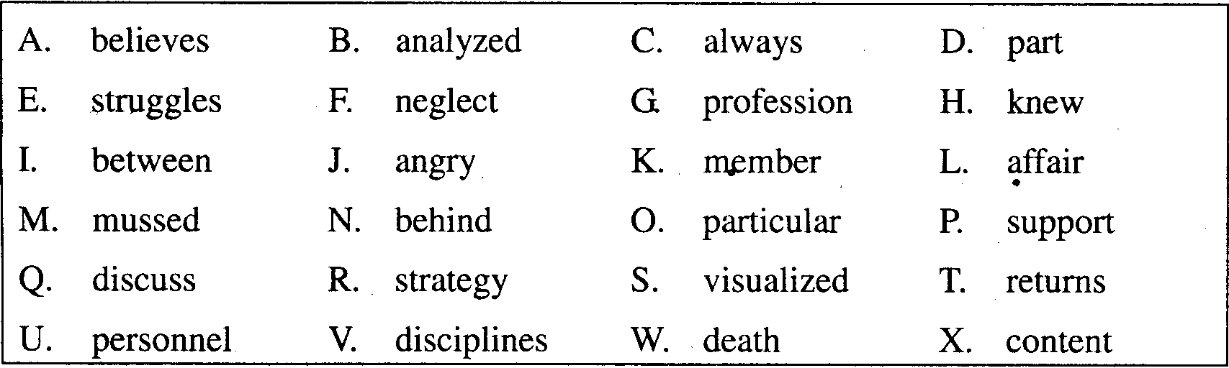
III. Each of the following sentences is given two choices of words or expressions. Choose
the right one to complete the sentence and write the corresponding letter on your
Answer Sheet. ( 15 points, 1 point for each )
40. It is a challenge to tell these separate stories without losing overall ______.
A. convenience B. coherence
41. Eva was ______ grateful for his expertise.
A. exceedingly B. successfully
42. The crowded room was filled with lights, cameras, and ______ reporters.
A. acquisitive B. inquisitive
43. After his ______ became widely known, he decided not to run for re-election.
A. hypocrisies B. stories
44. Feminist campaigns around the state effectively unmasked the unofficial ______ culture of politicians, experts and administrators.
A. feminine B. masculine
45. When it feeds, its huge tongue ______ in and out of its tiny mouth.
A. flicks B. plucks
46. It became clear that a good manager in today’s world must have courage and a strong sense of ______.
A. integrity B. activity
47. From this revival came black and white abstract nature forms in all shapes and sizes, the beginning of her highly ______ style.
A. personal B. individualistic
48. Those who ______ a national culture respond that immigrant groups traditionally came to America precisely to put ethnic and religious strife behind them and to become Americans.
A. advocate B. advertise
49. In this complex process, those charged with drawing districts use ______ computer technologies to come up with the most favorable district boundaries.
A. sophisticated B. superficial
50. They searched for the most savage and ______ beasts to put into the cages, from which the fiercest monster might be selected for the arena.
A. restless B. relentless
51. Nothing pleased him so much as to make the ______ straight, and crush down uneven places.
A. crooked B. troubled
52. In 1908, perhaps disappointed with the rigidity of American art education at the time, she gave up painting and became a(n) ______ artist, drawing advertising illustrations in Chicago.
A. economical B. commercial
53. A research indicates that the highest current ______ levels are now found not in the South but in older northern smokestack cities.
A. disposition B. segregation
54. The ______ headlights of the cars could be seen through the fog.
A. gleaming B. shinning
Read the following passage carefully and complete the succeeding four items IV, V, VI and VII.
Fear of Dearth (缺乏)
(1) I hate jogging. Every dawn, as I thud around New York City’s Central Park reservoir, I am reminded of how much I hate it. It’s so tedious. Some claim jogging is thought conducive; others insist the scenery relieves the monotony. For me, the pace is wrong for contemplation of either ideas or vistas. While jogging, all I can think about is jogging—or nothing. One advantage of jogging around a reservoir is that there’s no dry shortcut home.
(2) From the listless looks of some fellow trotters, I guess I am not alone in my unenthusiasm: Bill-paying, it seems, would be about as diverting. Nonetheless, we continue to jog; more, we continue to choose to jog. From a practically infinite array of opportunities, we select one that we don’t enjoy and can’t wait to have done with. Why?
(3) For any trend, there are as many reasons as there are participants. This person runs to lower his blood pressure. That person runs to escape the telephone or a cranky spouse or a filthy household. Another person runs to avoid doing anything else, to dodge a decision about how to lead his life or a realization that his life is leading nowhere. Each of us has his carrot and stick. In my case, the stick is my slackening physical condition, which keeps me from beating opponents at tennis whom I overwhelmed two years ago. My carrot is to win.
(4) Beyond these completely different reasons, however, lies a deeper cause. It is no accident that now, in the last third of the twentieth century, personal fitness and health have suddenly become a popular obsession. True, modern man likes to feel good, but that hardly distinguishes him from his predecessors.
(5) With amusingly ridiculous myopia (目光短浅), economists like to claim that the deeper cause of everything is economic. Delightfully, there seems no marketplace explanation for jogging. True, jogging is cheap, but then not jogging is cheaper. And the scant and simple equipment which jogging demands must make it a marketer’s least favored form of recreation.
(6)Some scout-masterish philosophers argue that the appeal of jogging and other body-maintenance programs is the discipline they afford. We live in a world in which individuals have fewer and fewer obligations. The work week has shrunk. Weekend worship is less compulsory. Technology gives us more free time. Satisfactorily filling free time requires imagination and effort. Freedom is a wide and risky river; it can drown the person who does not know how to swim across it. The more obligations one takes on, the more time one occupies, the less threat freedom poses. Jogging can become an instant obligation. For a portion of his day, the jogger is not his own man; he is obedient to a regimen he has accepted.
(7)Theologists may take the argument one step further. It is our modern irreligion, our lack of confidence in any hereafter, that makes us anxious to stretch our mortal stay as long as possible. We run, as the saying goes, for our lives, hounded by the suspicion that these are the only lives we are likely to enjoy.
(8) All of these theorists seem to me more or less right. As the growth of cults and charismatic religions and the resurgence of enthusiasm for the military draft suggest, we do crave commitment. And who can doubt, watching so many middle-aged and older persons torturing themselves in the name of fitness, that we are unreconciled to death, more so perhaps than any generation in modern memory?
(9) But I have a hunch (预感) that there’s a further explanation of our obsession with exercise. I suspect that what motivates us even more than a fear of death is a fear of dearth. Our era is the first to anticipate the eventual depletion of all natural resources. We see wilderness shrinking; rivers losing their capacity to sustain life; the air, even the stratosphere (同温层), being loaded with potentially deadly junk. We see the irreplaceable being squandered, and in the depths of our consciousness we are fearful that we are creating an uninhabitable world. We feel more or less helpless and yet, at the same time, desirous to protect what resources we can. We recycle soda bottles and restore old buildings and protect our nearest natural resource—our physical health—in the almost superstitious hope that such small gestures will help save an earth that we are damaging. Jogging becomes a sort of penance for our sins of gluttony, greed, and waste. Like a hairshirt or a bed of naril, the more one hates it, the more virtuous it makes one feel.
(10)That is why we jog. Why I jog is to win at tennis.
IV. In this section, there are ten incomplete statements, followed by four choices marked A, B, C and D. Choose the best answer and write the corresponding letter on your Answer Sheet. (10 points, 1 point for each)
55. According to the passage, the author ______.
A. jogs regularly even though he doesn’t like it
B. chooses to jog so that he can keep fit
C. hates jogging because it makes him feel bored
D. has to jog because he is suggested to do so
56. How do some of the trotters feel about jogging?
A. It is worse than bill-paying.
B. Bill-paying is better than it.
C. Bill-paying can’t be worse than it.
D. It is exactly the same as bill-paying.
57. Which of the following is true?
A. People run in order to follow the trend.
B. People run for their respective reasons.
C. Running helps people make wise decisions.
D. Too many reasons cause the trend of running.
58. Economists are likely to think that ______.
A. the economic factor is more important than others
B. everything depends on economic development
C. economy leads to greater success in sports
D. nothing is more important than economic claim
59. Which of the following is true about a marketer?
A. He doesn’t like jogging because the equipment is simple.
B. Among all the sports, jogging is the last one he wants.
C. Jogging is the only form of recreation he doesn’t like.
D. He can’t make much money from jogging equipment.
60. The shortened work week ______.
A. satisfies all the working people
B. provides people with too much free time
C. offers people more time to worship God
D. makes it hard for people to spend their time properly
61. The author’s tone about the economists is ______.
A. angry B. friendly
C. sarcastic D. sympathetic
62. According to theologists, people run because ______.
A. they are afraid of death B. they enjoy the activity
C. they want to live longer D. they are suspicious about religion
63. People are concerned about the natural resources because ______.
A. they are being destroyed B. they cannot be replaced
C. they are disappearing rapidly D. they are being replenished
64. The author ______ that the earth we live on ______.
A. is certain, can be saved by people’s action of recycling
B. is not sure, can become better by people’s small gestures
C. does not think, can be saved by what people are doing today
D. is hopeful, will become a better place with people’s efforts
V. There is one underlined part in each of the following sentences, followed by four choices marked A, B, C and D. Choose the one that is closest in meaning to the underlined part and write the corresponding letter on your Answer Sheet. (10 points, 2 points for each)
65. Some claim jogging is thought conducive; others insist the scenery relieves the monotony.
A. healthy B. profitable
C. helpful D. fashionable
66. That person runs to escape the telephone or a cranky spouse or a filthy household.
A. bad-tempered B. humorous
C. powerful D. ambitious
67. ... to dodge a decision about how to lead his life or a realization that his life is leading nowhere.
A. changes somewhere B. succeeds somehow
C. is hopeless D. is unsuccessful
68. And who can doubt, watching so many middle-aged and older persons torturing themselves in the name of fitness,…
A. for the sake of B. for the reason of
C. in the light of D. as a result of
69. But I have a hunch there’s a further explanation of our obsession with exercise.
A. strange enthusiasm for B. extreme unhealthy interest in
C. incredible commitment to D. positive attitude towards
VI. Translate the following sentences into Chinese and write the translation on your Answer Sheet. (10 points, 2 points for each)
70. While jogging, all I can think about is jogging—or nothing. One advantage of jogging around a reservoir is that there’s no dry shortcut home.
71. From a practically infinite array of opportunities, we select one that we don’t enjoy and can’t wait to have done with.
72. Freedom is a wide and risky river; it can drown the person who does not know how to swim across it. The more obligations one takes on, the more time one occupies, the less threat freedom poses.
73. Theologists may take the argument one step further. It is our modern irreligion, our lack of confidence in any hereafter, that makes us anxious to stretch our mortal stay as long as possible.
74. We see wilderness shrinking; rivers losing their capacity to sustain life; the air, even the stratosphere, being loaded with potentially deadly junk.
VII. Answer the following essay question in English within 80-100 words. Write your answers on the Answer Sheet. (10 points)
75. Nowadays, an obsessive devotion to strenuous physical activity is a prominent feature of modern life. What do you think are the reasons?
VIII. Translate the following sentences into English and write the translation on your Answer Sheet. (18 points, 2 points each for 76-80, 8 points for 81)
76．她的脸色通红、呼吸急促，我意识到她发高烧了。
77．我怀疑晚间电视新闻中的内容有多少是真正可吸收和可理解的。
78．与过去相比，现在更多的女人更长久地保持年轻的外貌。从这一点看，这是一个成 功。
79．她以前从未这样想过，然而这解释了她为什么每周都要特意在同一时间离家的原 因。
80．我们的调查表明，当今没有哪家公司会通过面面俱到来取胜。
81．新潮势利虽不是我们这个时代独有，却已经变得空前重要。理由很简单，完全是经 济原因。由于有了现代化机器，生产超过了消费。消费者有组织的浪费是我们工业繁荣的先决条件。对生产者来说，消费者扔得越快越好、买得越快越好。当然，与此同时，生产者必须做出自己的贡献——只生产最容易用坏的东西。

