全国2011年1月高等教育自学考试

外语教学法试题

课程代码：00833

请将答案填在答题纸相应位置上
I. Multiple Choices: (20%)
Directions: In this section, you are given 20 questions, beneath each of which are four choices marked A, B, C, and D. You are to make the best choice either to complete the incomplete statement or to answer the question. One point is given to each correct choice.
1. The Grammar-Translation Method came into being in the ______ century.
A. 16th B. 17th
C. 18th D. 19th
2. The generative-transformational school of linguistics emerged through the influence of ______.
A. J.B.Bruner B. N.Chomsky
C. D.Ausubel D. G.Kelly
3. In a ______ classroom, meaningful learning and meaningful practice are emphasized during the entire learning process.
A. Cognitive Approach B. Direct Method
C. Audiolingual Method D. Natural Approach
4. According to the records available, we believe that human beings have been involved in the study of language for at least ______ centuries.
A. 10 B. 15
C. 20 D. 25
5. Before the 16th century ______ was a language of communication, the world’s most widely studied foreign language in the Western world.
A. Latin B. German
C. French D. Spanish
6. According to Halliday, which of the following should NOT be accounted for in terms of linguistic events?
A. Form. B. Context.
C. Substance. D. Culture.
7. The structural linguists believed that the primary medium of language is ______.
A. written expression B. sign language
C. oral speech D. body pose
8. Students with the Grammar-Translation Method are expected to memorize grammatical rules and ______.
A. sentence patterns B. principles for translation
C. structures D. bilingual word lists
9. In an Audiolingual classroom, a dialogue is usually presented and memorized before specific ______ are picked out from it and later become the focus of drill exercises.
A. expressions B. phrases
C. grammatical patterns D. idioms
10. Features of communicative activities in a CLT classroom usually involve information gap, choice of form and content, and ______.
A. presentation B. discussion
C. conversation D. feedback
11. In the 1970s, Krashen's distinction between language acquisition and language learning and his ______ aroused widespread interest.
A. cognitive theory B. Monitor Model theory
C. schema theory D. whole-person learning theory
12. The criticism by those advocating the Communicative Approach was that teaching language with its focus on grammar produced structurally competent students who were often incompetent ______.
A. communicatively B. in society
C. in interpreting D. lexically
13. The neogrammarians, represented by______, formed the main linguistic basis of the Direct Method.
A. W. M. Wundt B. J.A. Comenius
C. F.Gouin D. Hermann Paul
14. In Krashen's view, acquisition refers to the ______ process leading to the development of competence and is not dependent on the teaching of grammatical rules.
A. conscious B. unconscious
C. overconscious D. subconscious
15. Who advocates the Total Physical Response Method?
A. J. Asher. B. C. Gattegno.
C. C. A. Curran. D.G. Lozanov.
16. In both the Direct Method and the Oral Approach, grammar is taught ______.
A. deductively B. inductively
C. positively D. negatively
17. In a Natural Approach class, which of the following is NOT an acquisition activity?
A. Affective-humanistic activity. B. Problem-solving activity.
C. Content activity. D. Translation activity.
18. Of the nine fundamental principles of good language teaching and learning proposed by Palmer, ______ is the first and most important.
A. vocabulary buildup B. phonetic practice
C. habit formation D. grammar acquisition
19. In the Oral Approach, the teacher does NOT perform the role of a ______.
A. model B. manipulator
C. monitor D. commander
20. The Direct Method emerged as a result of ______ in the 19th century.
A. classroom instruction B. mass production
C. communicative needs D. language teaching innovations
II. Filling blanks: (20%)
Directions: In this section, there are 20 statements, each of which contains a blank. You are to fill in each blank with ONE appropriate word. One point is given to each blank.
21. Suggestopaedia, the application of the study of ______ to pedagogy, has been developed to help students eliminate the feeling that they cannot be successful and thus to help them overcome the barriers to learning.
22. F.Gouin’s linguistic and psychological theories based on his observations of children’s use of language were directly applied to the practice of the ______ Method.
23. The major practice in a Grammar-Translation Method classroom is translating from and into the ______ language.
24. Most psychologists today agree with Freud to his general view that the unconscious ______ processes influence conscious thought and action.
25. The ultimate goal of an Audiolingual program is to develop in the learners the same types of abilities which ______ speakers have.
26. The ______ of instruction in the Grammar-Translation Method is the first language or mother tongue.
27. The ______ i + 1, put forward by Krashen, means that input contains structures slightly above the learner’s present level.
28. Krashen believes that language acquisition refers to the process in which the language learners develop their language ______ through natural communications in the target language.
29. The Direct Method got its name from the assumption that ______ are to be connected directly with the target language, without going through the process of translating into the students' native language.
30. The input hypothesis claims that the best way to teach ______ is to focus on listening.
31. Ways of integrating language skills in a Communicative Approach classroom are listening and ______, oral presentation, project work, role-play and simulation, etc.
32. English 900 is a typical example of textbooks which provide materials for teaching and learning adopting the ______ Method.
33. It is believed in the Oral Approach that through repetitive drilling students can acquire oral ______ of the target language.
34. The Oral Approach aims at ______ practice of situations and automatic use in speech, reading and writing on the part of learners.
35. Chomsky rejected the behaviorist model of language acquisition on the basis of his model of competence and ______.
36. Both the generative transformational and cognitive theories have recognized a ______ as an orderly system of rules which a learner can consciously acquire by study methods.
37. Since the end of World War II, teachers have found themselves under considerable pressure to abandon the long-standing ______ model, though it had been in general use in second language teaching since the late 18th century.
38. People in communication must recognize the social setting, their relationship to the others, and the types of language that can be used for a particular ______.
39. The linguist's task, according to the ______, was to describe human languages and to identify the structural characteristics of those languages.
40. The learning of a foreign language was viewed by the Direct Methodologists as analogous to the language ______, and the learning processes involved were often interpreted in terms of an associationist psychology.
III. Matching: (10%)
Directions: This section consists of two groups of pairs listed in two columns, A and B. You are to match the one marked ①, ②, ③, ④, or ⑤ in Column A with the one marked a, b, c, d, or e in Column B. One point is given to each pair you match correctly.
41.
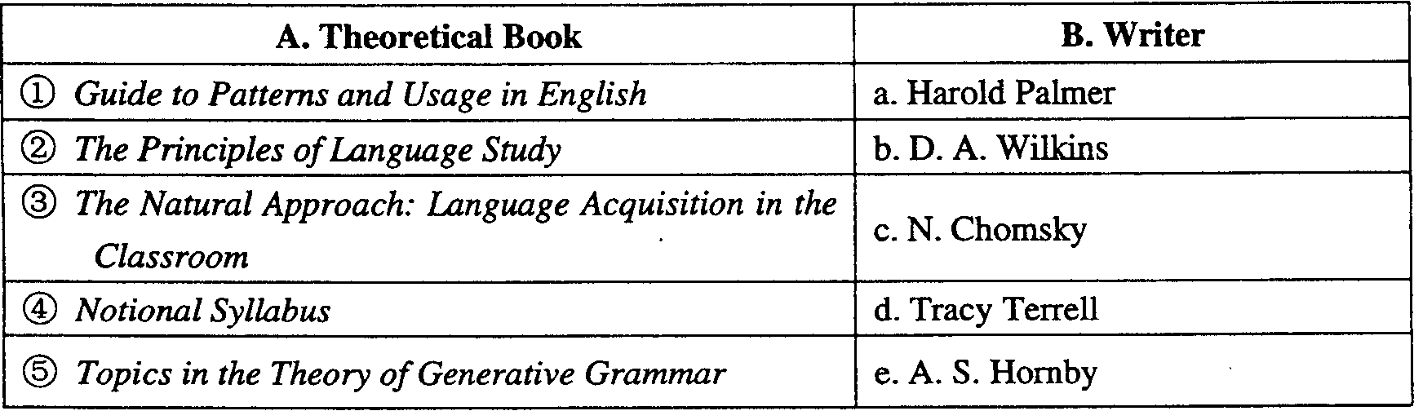
42.
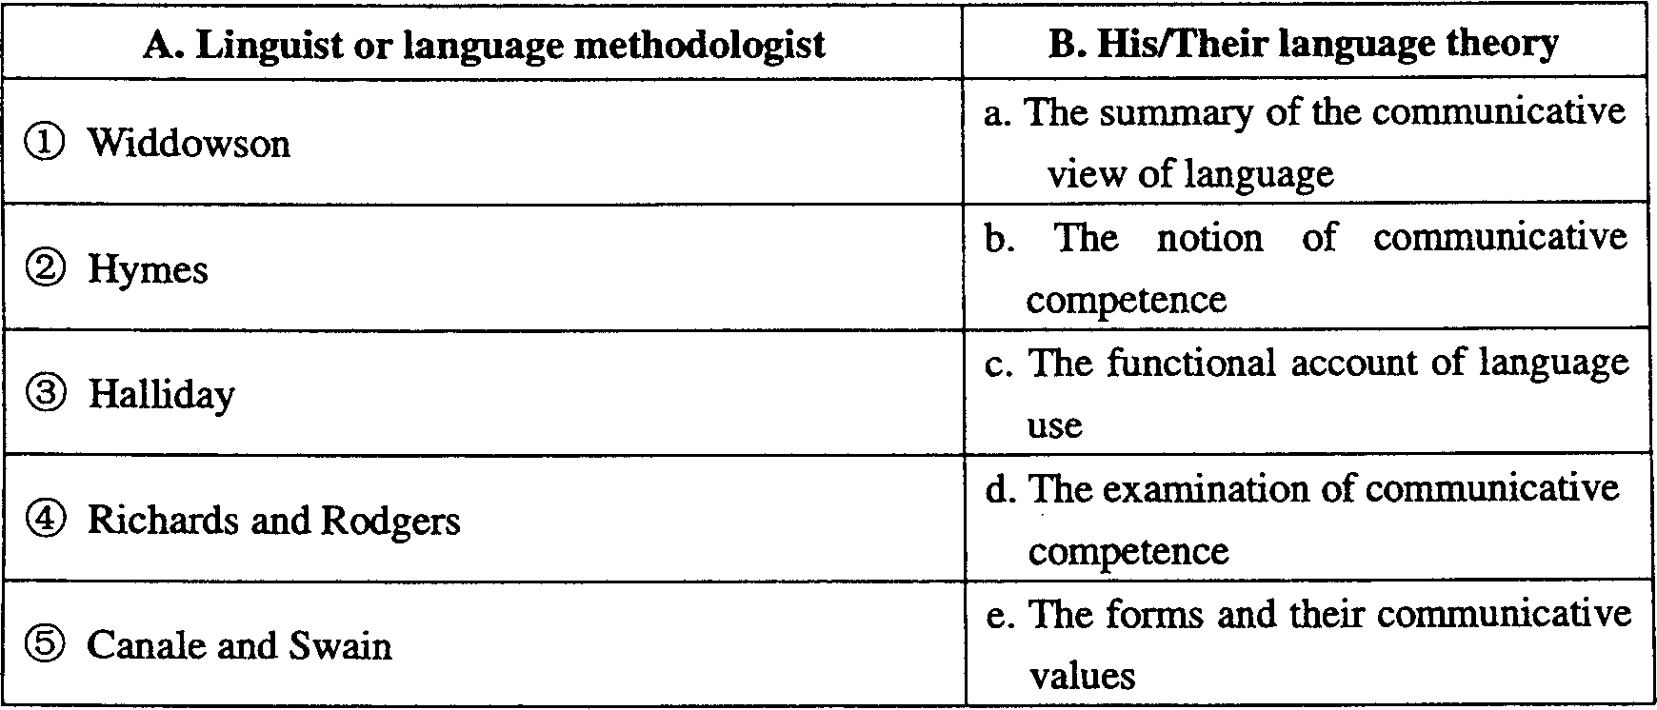
IV. Questions for Brief Answers: (30%)
Directions: This section has six questions. You are to answer them briefly. Five points are given to each question.
43. What is the learning theory of the Direct Method according to Comenius?
44. What are the two objectives Harold Palmer tried to work out during his teaching of English in Japan?
45. What are the three main teaching activities in a Grammar-Translation Method classroom?
46. According to the Natural Approach, what can the learner decide to do in terms of the actual use of the target language?
47. The general purpose of the Communicative Approach is to develop the students' communicative competence, which includes four aspects of knowledge. What are they?
48. There are two major phases in a Suggestopaedia classroom. What are they? And what is the purpose of the second major phase?
V. Questions for Long Answers: (20%)
Directions: The two questions in this section are to be answered on the basis of your own teaching experience as well as the theoretical knowledge you've learned. Ten points are given to each question.
49. What is the fundamental task of Foreign Language Teaching Methodology?
50. What is the attitude of the Cognitive Approach towards mistakes in the language learning process?

