全国2011年10月高等教育自学考试
外语教学法试题
课程代码：00833
请将答案填在答题纸相应的位置上
Ⅰ. Multiple Choices: (15 %)
Directions: In this section，you are given 15 questions，beneath each of which are four choices marked A，B，C，and D. You are to make the best choice either to complete the incomplete statement or to answer the question. One point is given to each correct choice.
1. In the 19th century，foreign language teachers usually adopted the strategy of combining grammar roles with ______.
A. reading B. speaking
C. writing D. translating
2. Teachers in a/an ______ classroom are encouraged to show approval for each and every correct performance by their students，and the drills are designed to produce success for the students.
A. Grammar-Translation B. Situational
C. Audiolingual D. Communicative
3. English 900 is a typical example of textbooks which provide materials for teaching and learning adopting ______ Method.
A. Grammar-Translation B. Audiolingual
C. Direct D. Situational
4. One of the objectives by the Natural Approach is to enable the students to make the meaning clear but not necessarily be ______ in all details of grammar.
A. correct B. accurate
C. brief D. concise
5. The Cognitive Approach holds that students’ mistakes are ______ in the creative use of language.
A. useful B. understandable
C. unavoidable D. reasonable
6. According to the Natural Approach，______plays only the insignificant function to convey meaning.
A. form B. vocabulary
C. grammar D. phonetics
7. English teaching in China didn’t enter into the formal educational system until the ______ century.
A. late 19th B. early 20th
C. mid-20th D. late 20th
8. Palmer and his fellow linguists believed that a mastery of some ______ words would greatly assist foreign language learning.
A. 1,000 B. 2,000
C. 3,000 D. 4,000
9. The Communicative Approach lays emphasis on learning to communicate through ______ in the target language.
A. listening and note-taking B. interaction
C. role play D. oral presentation
10. The best-known reformer in the mid-19th century is ______，who developed an approach to teaching a foreign language on the basis of his observations of child first language learning.
A. M. D. Berlitz B. W. M. Wundt
C. J. A. Comenius D. F. Gouin
11. In foreign language teaching，the target language was interpreted as a system of rules to be observed in texts and sentences，and to be related to the first language ______ and meaning.
A. words B. rules
C. sentences D. context
12. In the Direct Method，teachers encourage learners to ______ rules of grammar through active use of the target language in the classroom.
A. apply B. analyze
C. induce D. paraphrase
13. Which of the following dictionaries is a great contribution made by Homby to EFL teaching?
A. Longman Dictionary of Contemporary English.
B. The Concise Oxford Dictionary.
C. Everyman’s English Pronouncing Dictionary.
D. The Advanced Learner’s Dictionary of Current English.
14. The generative linguist is interested not only in ______ language but also in explaining language.
A. teaching B. describing
C. using D. understanding
15. According to M. A. K. Halliday，which of the following should NOT be accounted for in terms of linguistic events?
A. Form. B. Context.
C. Substance. D. Culture.
Ⅱ. Filling Blanks: (20 %)
Directions: In this section，there are 20 statements with 20 blanks. You are to fill each blank with ONE appropriate word. One point is given to each blank.
16. Bloomfield and Fries were known as the representatives of the ______ linguistics.
17. The Natural Approach advocates that language teaching should emphasize ______ rather than form.
18. According to Skinner，a renowned behaviorist psychologist，______ was much more effective than punishment in a teaching situation.
19. The Direct Method got its name from the assumption that ______ are to be connected directly with the target language，without going through the process of translating into the students’ native language.
20. A major feature of ______ code-learning is the emphasis on explanations of grammatical functioning.
21. Asher，the advocate of the Total Physical Response method，views the verb，and particularly the verb in the ______，as the central element around which language use and learning are organized.
22. Krashen regards provision of comprehensible ______ and reduction of stress as keys to successful language acquisition.
23. The establishment of a laboratory of ______ psychology announced the official birth of the science.
24. The neogrammarians，represented by Hermann Paul，formed the main linguistic basis of the ______ Method.
25. The experts in grammar analysis and translation approach believed that the human minds could be trained by logical analysis of the classic language，memorization of complicated rules，and ______ between languages.
26. Books such as A Grammar of Spoken English on a Strictly Phonetic Basis，A Handbook of English Grammar，Guide to Patterns and Usage in English served as a standard ______ source of basic English sentence patterns for textbook writers.
27. The Cognitive Approach lays emphasis on innate organizing principles in human perception and ______.
28. Notions，according to Van Ek and Alexander，are domains in which we use ______ to express thought and feeling.
29. Cognitive psychologists hold that language learning is the discovery of the underlying ______ of the language by means of inductive and deductive inference.
30. Chomsky divides the grammar of a ______ language into core grammar and peripheral grammar.
31. The fundamental purpose of learning Latin was to study the ______ culture which was worshipped in the Renaissance.
32. In the Natural Approach，to ______ stress，learners are not required to speak until they feel ready，but they are expected to make responses in other ways.
33. Some British linguists emphasized the close relationship between the ______ of a language and the context and situation in which the language was used.
34. The Natural Approach considers ______ as the most important element of any language teaching program.
35. Two indispensable parts of Communicative Language Teaching are supposed to be discourse analysis and ______.
Ⅲ. Matching: (15 %)
Directions: This section consists of three groups of pairs listed in two columns，A and B. You are to match the one marked ①，②，③，④ or ⑤ in Column A with the one marked a，b，c，d or e in Column B. One point is given to each pair you match correctly.
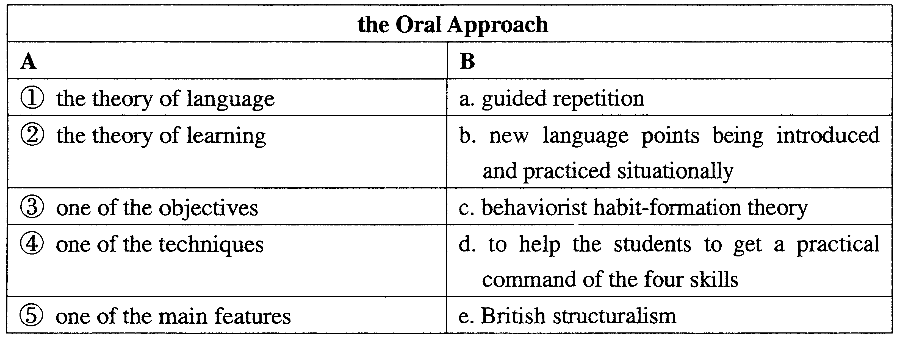
36.

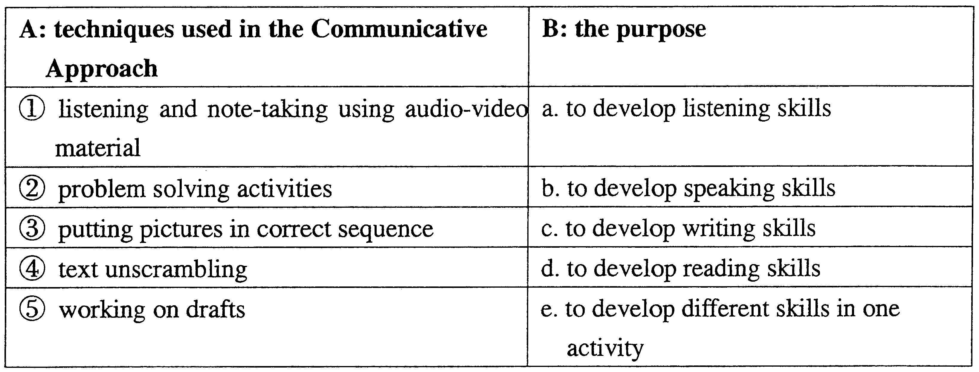
37.

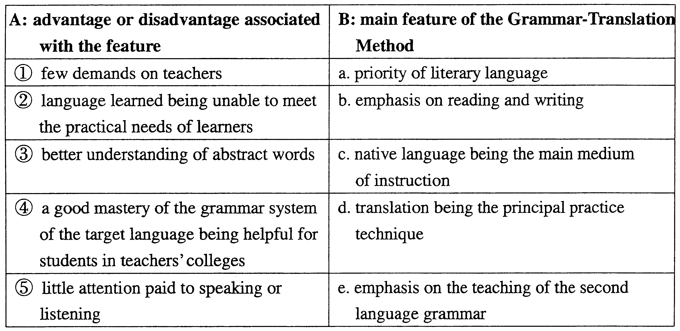
38.

Ⅳ. Questions for Brief Answers: (30%)
Directions: This section has six questions. You are to answer them briefly. Five points are given to each question.
39. Could you please name any two of Daniel Jones’ works on English phonetics?
40. What is the learning theory of the Direct Method according to J. A. Comenius?
41. How does the teacher mat practices the Oral Approach deal with students’ errors?
42. What is language in Chomsky’s opinion?
43. What is the primary goal of the Natural Approach?
44. What are the four points summarized by Tang Lixing on the methodological development before the 1980s in China?
Ⅴ. Questions for Long Answers: (20%)
Directions: The two questions in this section are to be answered on the basis of your own teaching experience as well as the theoretical knowledge you’ve learned. Ten points are given to each question.
45. Discuss in your own words the advantages of the Direct Method.
46. What are the principles that Asher believes in?

