全国2011年4月高等教育自学考试
英语科技文选试题
课程代码：00836
PART A：VOCABULARY
I. Directions：Add the affix to each word according to the given Chinese，making changes when necessary. (10％)
1. relevant 不相干的 1. _________________
2. permanence 永久地 2. _________________
3. opt 可选的 3. _________________
4. division 细分 4. _________________
5. normal 异常的 5. _________________
6. verify 鉴定(名词) 6. _________________
7. system 生态系统 7. _________________
8. symbol 作为…的象征 8. _________________
9. gravity 引力的 9. _________________
10. connect 使互相连接 10. _________________
Ⅱ.Directions：Fill in the blanks，each using one of the given word or phrases below in its proper form.(12％)
delve into regard as at work a sense of
run down comply with for the sake of stand for
in addition expose to wipe out in contrast
11. It’s hot in the day time，but __________ it’s very cold at night. 
12. I need your help. __________，I need her support. 
1 3. Mary said she was tired of journalists’ digging and __________ her private life. 
14.Computers will be hard __________ on these problems.
15. She doesn’t sleep enough，so she always has __________ fatigue. 
16.Kate __________ new ideas when she went to college.
17. The library __________ all important part of public service in the city. 
18.She tried to look healthy __________ her husband. 
19. The battery has __________.
20.These tropical diseases can __________ the populations of whole villages. 
21. He promised to __________ my request. 
22. What do the letters PTO __________?
III. Directions：Fill in each blank with a suitable word given below. (8％)
through obtain for with about discipline perform system
Computer vision is the science and technology of machines that see. As a scientific 23 ，computer vision is concerned 24 the theory and technology for building artificial systems that 25 information from images or multi-dimensional data. A significant part of artificial intelligence deals with planning 26 systems which can 27 mechanical actions such as moving a robot 28 some environment. This type of processing typically needs input data provided by a computer vision 29 ，acting as a vision sensor and providing high-level information 30 the environment and the robot. Other parts which sometimes are described as belonging to artificial intelligence and which are used in relation to computer vision are pattern recognition and learning techniques. 
23. __________ 24. __________ 25. __________ 26. __________
27. __________ 28. __________ 29. __________ 30. __________
PART B：TRANSLATION
IV. Directions：Translate the following sentences into English，each using one of the given words or phrases below. (10％)
burst forth to the tune of deficient as to bring. . . into play
31. 我们应该调动一切积极因素，进行必要的社会改革。
32. 人群中突然发出令人恐怖的叫喊声。
33. 他的信通常很长，有时多达30页。
34. 因为缺少资金，他不能成立自己的公司。
35. 至于写什么，约翰还没有得到任何明确的指示。
V. Directions：Translate the following paragraph into Chinese.(15％)
36. The things that chemists actually do to investigate the properties and reactions of matter vary widely, and are constantly undergoing change as new methods are developed，new equipment is invented，and new techniques devised. The introduction of the high-speed computer, for example，made it possible to investigate a number of problems that could not previously be tackled. In the past thirty years，with the use of the computer, we have been able to elucidate the structure and function of many proteins and other macro-molecules of biological importance. The substances chemists study vary widely, and are constantly changing. Because of this it has humorously been suggested that “chemistry is what chemists do. ”
PART C：READING COMPREHENSION
VI. Directions：Read through the following passages. Choose the best answer and put the letter in the bracket.(20％)
(A)
A few years ago，the first atom lasers were built，devices that produce a beam of atoms with many of the properties of a laser beam. Now physicists at the Max Planck Institute for Quantum Optics and the Ludwig-Maximilians-Universitaet in Munich have demonstrated that atom lasers can be integrated on a microchip. This result dramatically simplifies the production of laser-like matter waves，and call be compared to the step from single transistors to integrated microelectronics. The new devices are expected to become key components in future technologies ranging from ultraprecise measurements to quantum information processing. 
Quantum mechanics has taught us that atoms behave like waves, spreading out in space and being able to interfere much like light waves do. The tiny size of these matter waves and their fast and irregular movement play together to hide them from even a microscope’s view under normal conditions. This changed dramatically when the first “atom lasers” were built a few years ago. By realizing a phenomenon known as “Bose-Einstein condensation” physicists were able to put thousands of atoms into the same quantum state，and to take real-life images of this amplified atomic matter wave with an ordinary video camera. Many scientists believe that Bose-Einstein condensates and atom lasers will lead to revolutionary new technologies，just as laser has revolutionized fields as diverse as eye surgery, consumer audio electronics and high-speed telecommunication. However, much like the early lasers，the first atom lasers were bulky machines that filled entire research laboratories. Indeed，to suspend the cloud of atoms，they used large，water-cooled electromagnets that consumed as much electrical power as a few dozen “hair dryers”. Moreover, the most advanced vacuum technologies were needed to isolate the atoms from their environment while they were being cooled down to the near-absolute zero temperature which is required for Bose-Einstein condensation. 
Now, researchers of the Max Planck Institute for Quantum Optics and the University of Munich have dramatically simplified atom laser construction by using a thumbnail-sized microchip to achieve Bose-Einstein condensation. In their experiments，the cloud of condensed atoms hovers just above the micron-sized gold wires which are inscribed on the chip. The microchip not only replaces the coils and cuts the power consumption to a small fraction of what it used to be. In addition，it drastically shortens the time required to produce the condensate，from about a minute to a few seconds. This in turn relaxes the stringent vacuum requirements of the older experiments. 
But the new technique has another advantage，which may well turn out to be the most important one. Just as in microelectronics，many “atom-optical” components may be integrated on a single chip. In these first experiments already, the Munich researchers have successfully transported the fragile matter waves along the chip surface，using a special arrangement of microwires to create a “magnetic conveyor belt”. 
37.What does the passage mainly discuss? ( )
A. Bose-Einstein condensation. 
B. Revolutionary new technologies.
C. Atom lasers. 
D. Integration of atom lasers on a microchip.
38. T11e word “microchip” in line 4，para.1，refers to ______. ( )
A. a scrap
B. a silicon chip
C. a computer part
D. a chip that can’t be seen with the naked eye
39. Why can’t atom waves be seen through a microscope under normal conditions?( )
A. Because of their small size and fast and irregular movement. 
B. Because of their spreading out in space. 
C. Because of their interference like light waves. 
D. Because of Bose- Einstein condensation. 
40. what does the author think of the first atom lasers according to the passage? ( )
A. They led to revolutionary new technologies. 
B. They were significant in medicine，electronics and telecommunication. 
C. They were too big. 
D. They made a difference to quantum mechanics. 
4 1. Which of the following is NOT true about the new technique of atom laser construction?
( )
A. It is an advance from single transistors to integrated microelectronics. 
B. Many “atom-optical” components may be integrated on a microchip. 
C. There will be no more strict vacuum requirements. 
D. It is no more time consuming to produce the condensate. 
(B)
Poultry workers in the United States are 32 times more likely to carry E. coli bacteria resistant to the commonly used antibiotic，gentamicin，than others outside the poultry industry, according to a recent study conducted by researchers at the Johns Hopkins Bloomberg School of Public Health. While drug-resistant bacteria，such as E. coli，are common in the industrial broiler chicken environment，this is the first U. S. research to show exposure occurring at a high level among industrial poultry workers.
“The use of antimicrobials in industrial food production has been going on for over 50 years in the United States，” said the study’s lead author, Lance B. Price，who serves on the research faculty at the Johns Hopkins School of Medicine，Division of Infectious Disease，and is a scientific advisor to the Johns Hopkins Center for a Livable Future. “Some estimates indicate that well over half of the antimicrobial drugs produced in the United States are used in food animal production. In the U. S. alone，over nine billion food animals are produced annually. ”
The study was conducted with poultry workers and community residents in the eastern shore regions of Maryland and Virginia，and it confirms similar studies in Europe showing that poultry farmers and workers are at risk of exposure to drug resistant E. coli bacteria. The Maryland and Virginia regions on the Delmarva Peninsula are among the top broiler chicken producing regions in the U. S.，producing more than 600 million chickens annually. 
In the study, researchers conducted in-depth analyses of 49 study participants，16 working within the poultry industry and 33 community residents. Stool samples from the participants were tested for resistance to the antimicrobials ampicillin，ciprofloxacin，ceftriazone，gentamicin and tetracycline. Findings showed that poultry workers had 32 times greater odds of being colonized with gentamicin-resistant E. coli than other members of the community. 
“One of the major implications of this study is to underscore the importance of the non- hospital environment in the origin of drug resistant infections,” said Ellen K.Silbergeld，PhD， senior author of the study. 
Price，PhD，and other researchers note that as food animal production shifted from the independent farmer to large-scale，industrialized operations，the use of antimicrobials in feeds intended to stimulate growth has increased. Currently 16 different antimicrobial drugs are approved for use in U. S. poultry production with gentamicin reported to be the most widely used. 42. What is the passage mainly about? ( )
A. Why poultry workers in the US are more likely to carry drug resistant E. coli bacteria. 
B. How bacteria are resistant to antimicrobial drugs.
C. Findings in a recent study with poultry workers and community residents. 
D. Food animal production in the US. 
43. The expression “broiler chicken’’ in line 4，para.1，refers to ______. ( )
A. chicken kept in a broiler
B. chicken reared for marketing
C. chicken suitable for roasting
D. chicken suitable for stewing
44. Why are antimicrobials used widely in poultry production? ( )
A. To create a non-hospital environment for the poultry. 
B. To increase the number of poultry. 
C. To prevent contagious diseases. 
D. To help the poultry to grow. 
45. How was the study conducted with poultry workers and community residents?( )
A. By thorough analyses. 
B. By stool examination.
C. By follow-up visits. 
D. B y comparison with the studies in Europe. 
46. What does Ellen K.Silbergeld mean when stating that “One of the major implications of this study is to underscore the importance of the non-hospital environment in the origin of drug resistant infections”? ( )
A. The non-hospital environment is not so important in the origin of drug resistant infections.
B. It is very important to know why drug-resistant infections occur outside hospital. 
C. It is the non-hospital environment that determines the origin of drug resistant infections. 
D. It should be emphasized that the non-hospital environment call be the origin of drug resistant infections. 
VⅡ. Directions：Read the following passage，and then fill in the table with the information based on the passage. (10％)
Simulated diamonds are a creation of man；they are formed via a technological process. That is why they are also known as “manufactured”，“lab-grown” or “cultured” diamonds. In 1797 it was first discovered that diamonds are comprised of pure carbon. Ever since then，attempts have been made by several people to produce diamonds synthetically. 
There are two major methods which are used to create simulated diamond crystals. The first and most popular method，which was devised by GE，is known as the High Pressure High Temperature （HPHT）method. There too，there are two different press designs which are used to grow the diamond crystals. The first is the method used by Howard Tracy Hall，which is called the belt press method. In the belt press method，two anvils，one from up and one from down，supply the pressure and heat currents to a cylindrical volume. The second method is known as the cubic press method. In this method，there are six anvils which provide pressure to a cube shaped volume. The second method，devised by the Japanese，is known as Chemical Vapor Deposition(CVD)method. In this method the necessary environment is created for carbon atoms in a gas to settle on a surface for the diamond crystals to grow.
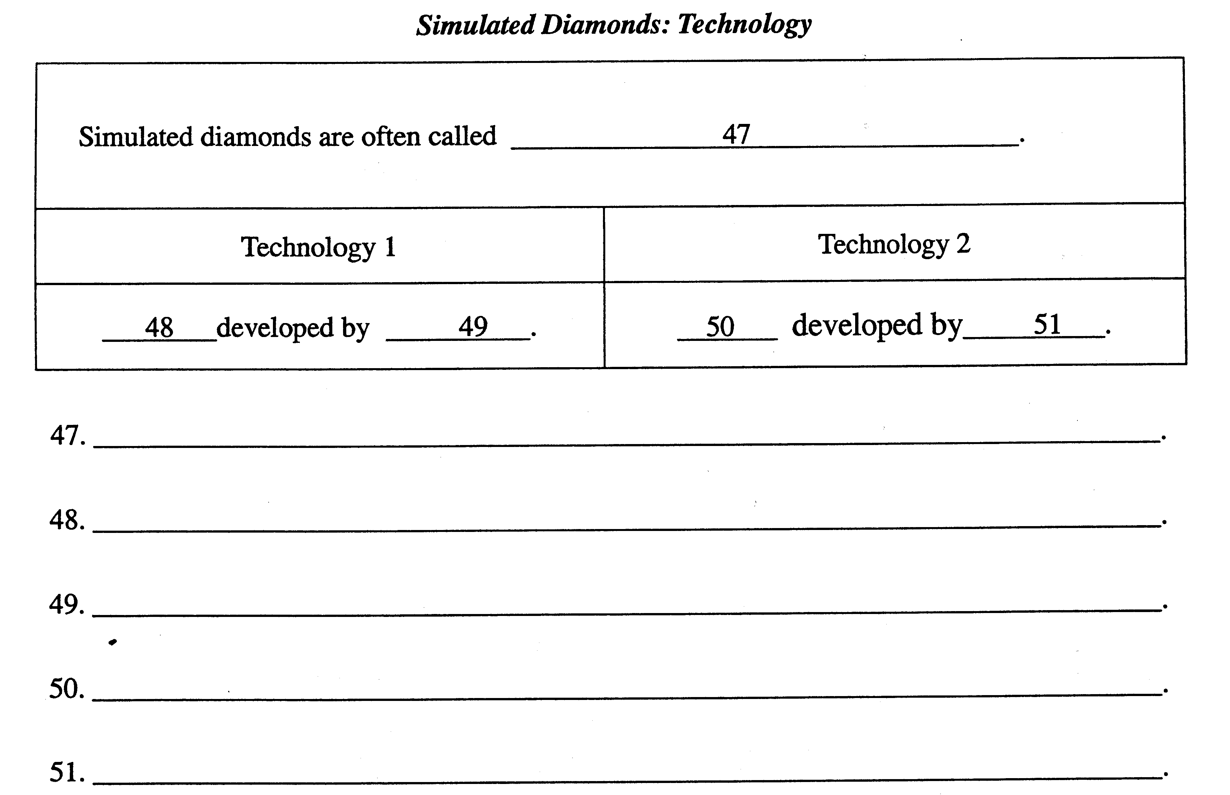

PART D：WRITING
VIII. Directions：Write a passage(150-200 words) in English on the following title. Develop the ideas according to the Chinese outline given below. (15％)
52. Should Cars Be Allowed into College Campus?
(1)现在拥有私人汽车的人越来越多。
(2)某些大学禁止小汽车驶入和停放在校园里。
(3)你的看法。

