浙江省2008年7月高等教育自学考试
旅游英语试题
课程代码：06010
本试卷分A、B卷，使用2002年版本教材的考生请做A卷，使用2007年版本教材的考生请做B卷；若A、B两卷都做的，以B卷记分。
A卷
Ⅰ.Make the best choice to complete the following sentences. (20%)
1. This mountain range has many high ________ and fertile valleys. ( )
A. peaks B. hills
C. phases D. pink
2. ________ industry has three supporting parts like hospitality, travel agency and transportation.
( )
A. Hospitality B. Tourism
C. Catering D. Transportation
3. Milk, butter, and cheese are ________ here from the farms. ( )
A. imported B. transferred
C. transformed D. transported
4. We all ________ your coming to help us. ( )
A. appropriate B. appreciate
C. admit D. affect
5. What they are ________ about is which comes first: the chicken or the egg? ( )
A. summing B. striking
C. stirring D. arguing
6. I certainly didn’t intend to ________ your plans. ( )
A. upset B. shake
C. shave D. drag
7. If you want a pen, look inside the ________of the desk. ( )
A. box B. drawer
C. major D. melt
8. Under no ________ will I go there again. ( )
A. circumstances B. situation
C. giant D. happen
9. This supermarket developed rapidly under his ________. ( )
A. administration B. suggestion
C. approach D. appearance
10. That radio company is so big that it has many ________ in foreign countries.( )
A. introducers B. instructors
C. conductors D. agents
11. During these ten years, many new methods have been ________ in the new travel methods in tourism. ( )
A. adopted B. adapted
C. alarmed D. aided
12. That is ________ behavior and nobody likes it. ( )
A. whistle B. structural
C. selfish D. fur
13. Yesterday was such a ________ day we decided to go to the new travel destination. ( )
A. glorious B. dynamical
C. avenue D. invitation
14. Most people say that The Yellowstone is a ________. ( )
A. mystery B. smart
C. furniture D. custom
15. They serve ________ food in this restaurant. ( )
A. castle B. glue
C. delicious D. wing
16. We are leaving this afternoon, but we have not ________ our suitcases yet. ( )
A. trapped B. insulted
C. packed D. invited
17. The ________ of the hotel is beautifully painted. ( )
A. underneath B. well
C. interior D. image
18. A general ________ is held in the United States every four years. ( )
A. selection B. choice
C. election D. choose
19. His friend was injured in an airplane ________. ( )
A. break B. crash
C. fail D. falling
20. I am a new ________. I was hired in the Front Office in this hotel yesterday. ( )
A. employer B. employee
C. employment D. fence
Ⅱ.Decide whether the following statements are true or false. Write T for True and F for False. (20%)
1. A business letter is still the most reliable and the most respectful form of business communication and shall remain so in the foreseeable future. ( )
2. “Franchise” means independence shop. ( )
3. The apparent tendency of overlooking the need of acquiring the basic skills of business letter writing in the travel industry has hurt many young people. ( )
4. Transportation industry is a very important part of tourism. ( )
5. “CP Air” stands for the Canadian Pacific Airlines. ( )
6. “Glittering” means dark. ( )
7. “Promotion” in the travel industry refers to efforts of a company or destination area to create favorable public image also called “promo”. ( )
8. Quotation used in travel usually includes the fee for room and board, admissions, transportation, guides, etc. ( )
9. “Convention center” refers to a place or building where large gatherings of people meet to discuss the business of their organization or political group. ( )
10. Cocktail is a kind of soft drink. ( )
11. “To complement” used as a verb to mean enhance or to add desirable qualities in each other or to reduce the weakness in each other. ( )
12. “Please do not hesitate to contact us” is a useful expression commonly found in business correspondence. ( )
13. “Chancellor” means the president of the university. ( )
14. “Tour desk” is the table put in the guest room in hotel. ( )
15. “Hospitality industry” is a general term for hotel industry. ( )
16. The heading in a business letter refers to the address and the date of writing the letter on the part of the sender. ( )
17. “Whim” always can come into truth. ( )
18. When writing or typing the inside address and indeed the outside address, it is safe to copy the address given in the incoming letter. ( )
19. The salutation, which is the complimentary greeting right before the body of the letter, runs parallel to the letter body. ( )
20. The motivation for people to travel means the reason why they travel. ( )
Ⅲ.Match each word or phrase in the column on the left with its meaning in the column on the right. (15%)
( )1. grand a. say hello to
( )2. angry b. store up
( )3. exact c. accurate
( )4. escape d. accuse
( )5. adhere e. stick
( )6. gnaw f. advocate
( )7. individual g. contract
( )8. help h. aid
( )9. permit i. allow
( )10. flavor j. taste
( )11. denounce k. flee
( )12. flat l. apartment
( )13. supporter m. bite
( )14. agreement n. characteristic
( )15. greeting o. big
Ⅳ.Choose a correct word or phrase to complete each of the following sentences.(9%)
a. clientele
b. confirmation
c. access to
d. view
e. retail
f. traveling
1. There was a good ________ of the countryside from the front of the bus.
2. ________ in the country is something he loves.
3. Only high officials had ________ the president.
4. His uncle is said to be an international ________.
5. There are a lot of outlets for the ________ of leather goods.
6. We are waiting for ________of the news.
Ⅴ.Answer the following questions according to the content of the reading (20%)
1.A standardized envelope format is given below, please tell what should be written at each position.（共8分）
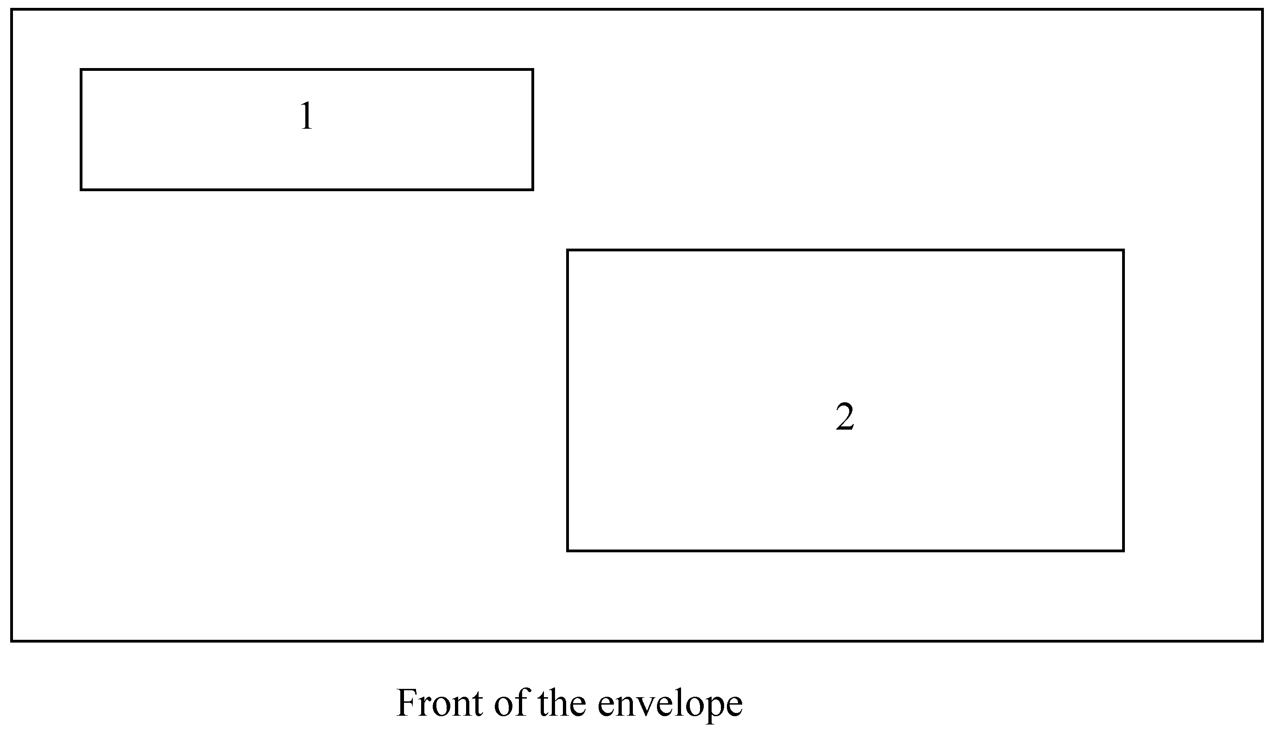
2.What are four major transportations in tourism? （6分）
3. What is the internet? Please give a brief answer. （6分）
Ⅵ.Translate the following sentences or phrases into English. (16%)
1. 我想托运这三件行李，这只短途旅行包我自己随身带。(4分)
2. 您的衣箱要进行检查，其余的可以随身携带。（4分）
3. 飞机在飞往洛杉矶的途中要停两个地方。（4分）
4. 这是你的药方，请按指示服药。（4分）
B卷
Ⅰ. Make the best choice to complete the following sentences.（20%: 本题型共20题，每题1分）
1. The agreement is to take ________ from the beginning of next month.( )
A. place B. position
C. charge D. effect
2. Is it a(n) ________ in this country to go out to pick flowers on the first day of spring?( )
A. habit B. custom
C. action D. movement
3. — Which of the two dictionaries will you borrow?
— I’ll borrow ________ for the different uses. ( )
A. all B. both
C. either D. neither
4. The problem of widespread unemployment is rather serious, so the local government has taken effective steps to ________ it.( )
A. put out B. set aside
C. deal with D. meet with
5. These programs are designed for those young people who want to ________ higher education but do not have enough time to go to university.( )
A. insure B. persist
C. inquire D. pursue
6. She touched her daughter gently ________ shoulder.( )
A. in her B. on her
C. in the D. on the
7. ________ production up by 60%, the company has had another excellent year.( )
A. As B. For
C. With D. Through
8. The teacher is writing ________ a piece of chalk on the blackboard while the students are writing ________ink in exercise books.( )
A. with, in B. in, with
C. in, in D. with, with
9. If we ________ to deal with these problems now, things will get out of control.( )
A. fail B. miss
C. delay D. deny
10. Then the doctor ________ my temperature and felt my pulse.( )
A. examined B. took
C. held D. measured
11. There is no ________ in going to the cinema now as the film has already started.( )
A. reason B. cause
C. motive D. point
12. —Take this medicine three times a day, Tom.
—Do I have to take it? It ________ so terrible.( )
A. is tasting B. is tasted
C. tastes D. has tasted
13. It won’t long before such a thing ________ again.( )
A. will happen B. happens
C. is happen D. happened
14. I am writing ________ my mother to express her thanks for your gift.( )
A. in memory of B. with respect to
C. on behalf of D. on account of
15. I’m sorry, sir. Your recorder isn’t ready yet. It ________ in the factory. ( )
A. is being repaired B. is repaired
C. has been repaired D. hasn’t repaired
16. Every possible means ________, but none proves successful. ( )
A. has tried B. has been tried
C. is being tried D. tried
17. Gunpowder was discovered in the twelfth century, but________. ( )
A. man did not put it to use in war two hundred years later
B. until two centuries more it was used in war
C. not used in war until two hundred years later
D. in war did not use it two hundred years afterwards
18. It was not Tom’s ________ that he was late for school, because he was delayed by a traffic accident.( )
A. fault B. error
C. mistake D. failure
19. The meeting started on time. Thirty minutes ________ the chairwoman declared it closed.( )
A. after B. later
C. late D. latter
20. Experts from all parts of the world meet yearly in Hiroshima to ________ a conference on atomic war threats.( )
A. present B. attend
C. join D. participate
Ⅱ. Decide whether the following sentences are true or false. Write T for True and F for False.（20%: 本题型共20题，每题1分）
1. C2B stands for “business to clients”. ( )
2. The validity period of the domestic route open-date ticket is 60 days. ( )
3. The title of an agreement should be in full with no acronyms, and in capital letters. ( )
4. Most Chinese dishes contain more calories than Western food. ( )
5. The word “advertise” is derived from the Latin word “advertere” meaning “to turn the mind toward”. ( )
6. Hospitality industry refers to the tourism industry. ( )
7. Harmony is the central concept on the art of Chinese cooking. ( )
8. All children under the age 12 should pay the children discount fare, which is 10% of the adult fare. ( )
9. Only when traveling in China can westerners taste more varieties of authentic Chinese food.
( )
10. Block Form is the most traditional form of a business letter. ( )
11. Different tastes of the herbs have different medicinal functions. ( )
12. In China, punctuality is regarded as a virtue, especially in the business world. ( )
13. Domestic passengers should produce their identity cards and flight tickets for check-in procedure. ( )
14. In ancient China, a marriage was decided by both the love of the young couple and the parents’ desires. ( )
15. Kites first appeared about 1500 years ago in China. ( )
16. Bank of China is the most common and safest place to make the currency exchanges in China.
( )
17. Four-star hotels in China offer spacious and luxurious rooms with its quality and attention to detail. ( )
18. Phone answering skills are extremely important for every business, and the way you answer your company’s phone will form your customer’s first impression of your business. ( )
19. Chinese calligraphy and Chinese painting are closely related because lines are used in both.
( )
20. Known as China’s national opera, Beijing Opera, which originated in the late 18th century, is a combination of music, dance, art and acrobatics. ( )
Ⅲ. Match each word or phrase in the column on the left with its meaning in the column on the right.（12%: 本题型共12题，每题1分）
( ) 1. hospitality a. scenic spot
( ) 2. complain b. usually
( ) 3. historic treasures c. cause
( ) 4. tourist attraction d. welcoming behavior towards guests
( ) 5. nutrition e. a meal which people serve for themselves
( ) 6. departure f. first; earliest
( ) 7. as a rule g. very valuable objects in history
( ) 8. buffet h. a person traveling on foot
( ) 9. considerate i. the process of giving or getting food
( ) 10. pedestrian j. an act of leaving
( ) 11. result in k. to express feelings of annoyance, unhappiness
( ) 12. original l. thoughtful
Ⅳ. Choose a correct word or phrase to complete each of the following sentences.（10%: 本题型共10题，每题1分）
a. Upgraded
b. destination
c. Firecrackers
d. Hotel general managers
e. cuisines
f. www. Ctrip.com
g. E-mail
h. telexes
i. Incentive travel
j. facilities
1. ________ established in Shanghai in April 1999, is a growing website in travel.
2. ________ is a scheme with which a business awards employees with good performance with a paid travel to go somewhere.
3. There are several less formal approaches to use, such as the exchange of letters, cables and ________.
4. Money exchange ________ are available at major airports, hotels, department stores.
5. Hong Kong SAR is highly developed, and a popular tourist ________.
6. ________ refers to the message sent from one computer to the other.
7. ________ is the status that the previous grade is uplifted to a high grade of service.
8. ________ are a must in the celebration of all Chinese festivals and on other important occasions.
9. ________ set room rates, provide funds to different departments and ensure high standards for customer services.
10. Chinese food can be divided into eight regional ________.
Ⅴ. Answer the following sentences according to the content of the reading. (22%)
1. Write down the full words for the following abbreviations:
USA, ATM, Dr (6%)
2. Put the following names of famous sites of Chinese tourism into English:
长江三峡， 兵马俑， 三潭印月 （6％）
3. Write a brief introduction to Hangzhou in about 80 words. (10%)
Ⅵ. Translate the following sentences into English. (16%: 本题型共4题，每题4分)
1. 说再见总是很难，可是就像中国人说的：“天下没有不散的筵席。”
2. 我们抱歉地通知您120航班因为天气原因被迫取消。
3. 在一些正式场合，握手更普遍，更适合。
4. 西湖的美一代又一代地激发了成千诗人画家的灵感，其中有著名的白居易和苏东坡。

