浙江省2009年7月高等教育自学考试
旅游英语试题
课程代码：06010
Ⅰ. Make the best choice to complete the following sentences. (16%)
1. I’d like to book a ticket ______ the 8∶15 flight. （ ）
A. in B. for
C. on D. at
2. The ticket might be falsely used by any person ______ the one named on the ticket. （ ）
A. besides B. other than
C. less than D. from
3. Make sure you have two pieces of identification, at least one of ______ must be issued by the government. （ ）
A. that B. those
C. which D. these
4. History has shown that criminals use passengers to carry bombs or other dangerous items ______. （ ）
A. on board B. above the board
C. overboard D. under the board
5. Even when it is not the case, hotels have ______ describing their offering in terms of the star-rating system. （ ）
A. taken off B. taken down
C. taken over D. taken to
6. Emily wasn’t sure if she had enough points to qualify ______ college admission. （ ）
A. at B. for
C. as D. to
7. Many problems! The sheets and the carpets are dirty; ... and the room still ______ cigarettes!
（ ）
A. smells of B. smells
C. hears of D. hears
8. They have similar responsibilities; they take reservations over the phone, greet customers ______, register arriving guests, and assign rooms. （ ）
A. by person B. as a person
C. in person D. to person
9. To be a hotel manager, you should have the ability to be ______ and diplomatic. （ ）
A. angry B. tactful
C. bitter D. jealous
10. All the suites have been carefully preserved in their ______ style of the 1930’s. （ ）
A. original B. shabby
C. messy D. difficult
11. That Guasha treatment removes blood stagnation and promotes health is still ______ me.
（ ）
A. beyond B. below
C. above D. over
12. In 2000, the medical association suggested that acupuncture ______ be made more readily available. （ ）
A. must B. should
C. has to D. will
13. When ______ the beauty of the night, they naturally remember the beautiful legends about the moon. （ ）
A. enjoyed B. is enjoying
C. enjoying D. are enjoying
14. What ______ to foreigners is probably the marvelous acrobatics. （ ）
A. appeals B. attracts
C. strikes D. surprises
15. They built this all in less than two years. In two years in Germany, we______ a plan for the evacuation (撤走) of the birds along the way. （ ）
A. would just have B. will just have
C. just have D. had just had
16. Another terminal is in the works, ______ for completion in time for the 2008 Olympics.
（ ）
A. due B. available
C. valid D. owing

Ⅱ. Decide whether the following statements are true or false. Write T for True and F for False. (30%)
1. An air ticket serves as a contract between an airline and a passenger. （ ）
2. Foreign currencies can be exchanged for Chinese yuan at any bank in China. （ ）
3. The Yellow River is one of China’s world famous natural wonders. （ ）
4. When travelers break a certain law of China, they will be sent back to their home country immediately. （ ）
5. Non-stop flight is the only safe way of air travel because air crashes happen at the take-off and landing of a plane. （ ）
6. The three oldest dramatic art forms in the world include Chinese operas, Greek tragic-comedy and Indian Sanskrit Operas. （ ）
7. Established by Tang Taizong, Liyuan that is Pear Garden was originally a Beijing Opera troupe.
（ ）
8. Chinese operas combine elements such as music, fashion, acrobatics, and literature. （ ）
9. Exaggeration and symbolism can best summarize the characteristics of Beijing opera.
（ ）
10. Originally, Huangmei Opera was a combination of folk songs and dances in Anhui Province.
（ ）
11. Huangmei Opera started as an opera about life of the common people and it is still struggling for national recognition. （ ）
12. Each herbal medicine prescription can treat different patients suffering the same disease.
（ ）
13. Different tastes of the herbs have different medicinal functions. （ ）
14. In ancient China, a marriage was decided by both the love of the young couple and the parents’ desires. （ ）
15. In China, punctuality is regarded as a virtue, especially in the business world. （ ）
16. The inside address is almost without exception identical to the recipient’s address on the envelope. （ ）
17. RSVP in an invitation letter means “contact us only if you are not able to come”. （ ）
18. Both the host and guest are referred to in the third person in formal invitations. （ ）
19. Travelers are not limited how much money they can bring to China if they use credit cards.
（ ）
20. When a Chinese nods his head, it does not necessarily mean he agrees with what is being said.
（ ）
Ⅲ. Match each word or phrase in the column on the left with its meaning in the column on the right. (14%)
（ ）1. outlet a. likely to explode
（ ）2. farewell b. craftsman
（ ）3. festivity c. goodbye
（ ）4. groom d. maltreat
（ ）5. vacuum e. a man on his wedding day
（ ）6. abuse f. place selling goods
（ ）7. explosive g. inside
（ ）8. artisan h. a statement of dissatisfaction
（ ）9. schedule i. celebration
（ ）10. complaint j. absence of air
（ ）11. interior k. timetable
（ ）12. routine l. holiday
（ ）13. cancel m. day-to-day
（ ）14. vacation n. withdraw
Ⅳ. Choose a correct word or phrase to complete each of the following sentences.(9%)
a. stocked with
b. subject to
c. Motels
d. average
e. regardless of
f. put through
1. They made up their minds to go on with the plan ______ all possible difficulties.
2. Every piece of luggage is ______ X-ray screening at the airport.
3. Sorry, sir, I can not decide this. May I ______ you ______ to the manager?
4. Though very small, the store is ______ almost anything we might need.
5. Hong Kong International Airport sees an ______ of more than 650 aircraft takeoff and landing each day.
6. ______are usually located along a roadway for use by people traveling by automobile.
Ⅴ. Identify parts 1 and 2 in the sample business letter and give them correct names (4%)
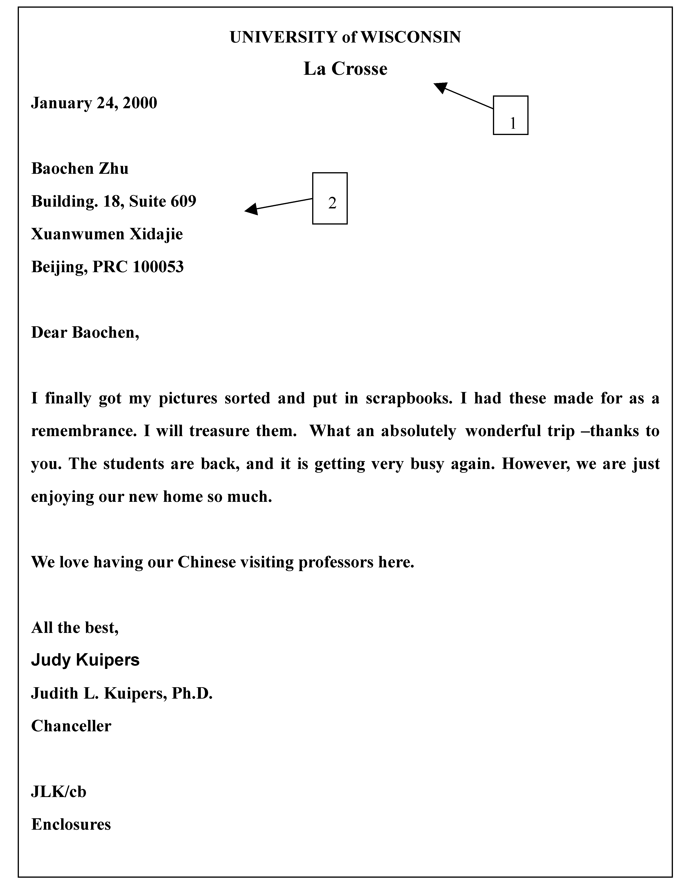
The six essential parts of a business letter include: (PART 1) ______ , (PART 2) ______ salutation, the body of the letter, the complimentary close and the signature.
Ⅵ. Fill in the blanks with proper words to complete the formal letter. (4%)
(Hints: Jerry Peters夫妇恭请David Smith夫妇于2009年7月4日晚上7点光临上海和平饭店共进晚餐。)
____________1
request the pleasure of the company of
____________2
on July 4th, 2009, at 7∶00 p.m.
at Shanghai Peace Hotel
Ⅶ. Write down the full words for the following abbreviations. (6%)
1. VIP __________________
2. TCM __________________
3. ID __________________
Ⅷ. Translate the following sentences or phrases into English. (17%)
1. 我们即将到达此次航程的终点。地面温度是摄氏/华氏**。(5分)
2. 台上一分钟，台下十年功。(5分)
3. 您关于中国文化的讲述让我们受益匪浅。（5分）
4. 红烧牛肉(2分)

