浙江省2010年7月高等教育自学考试
旅游英语试题
课程代码：06010
Ⅰ. Make the best choice to complete the following sentences. (16%)
1. The carrier shall not be liable to the passenger ______ on the ticket. ( )
A. name B. named
C. naming D. to name
2. Airline security staff will open a gift package if X-rays are unable to ______ its contents.
( )
A. make for B. make up
C. make up for D. make out
3. Be prepared to answer questions about whether you ______ your bags unattended at any time.
( )
A. might left B. might to leave
C. might leaving D. might have left
4. —May I suggest Beijing International Hotel?
—Ah, you are really ______. ( )
A. considerate B. considerable
C. considered D. considering
5. Speaker phones give the caller the impression that you’re not fully ______on his call. ( )
A. concentrating B. handling
C. listening D. competing
6. —I am the manager here. What can I do for you?
—______ anyone ______ the room before we moved in?( )
A. Has…checked B. Does…check
C. Had…checked D. Have…checked
7. Do calm down and tell me what the problem is. Then I will ______ how to help you. ( )
A. figure out B. put out
C. make out D. take out
8. Dealing with angry guests can be ______. ( )
A. stressful B. disappointed
C. fulfill D. inviting
9. They had to perform together with groups ______ in more popular forms like Beijing Opera.
( )
A. expert B. specializing
C. particular D. major
10. Do you know Bruce Lee, Jet Li or Jackie Chan, all famous Chinese film stars ______ in wushu? ( )
A. adept B. adopt
C. adapt D. adjust
11. Acupuncture was almost unknown in the US ______ President Richard Nixon’s trip to China.
( )
A. behind B. below
C. prior to D. as
12. Only after coping with these difficulties, ______ to see his wife-to-be. ( )
A. was he allow B. was he allowed
C. he was allowed D. he allowed
13. The bright clear weather and the joy of having harvest ______ a happy atmosphere. ( )
A. make for B. make up
C. make up for D. make out
14. In Germany, we______ endless discussion about maglev. Here in China, they just do it.
( )
A. have had B. had
C. have been having D. had had
15. When ______, it will provide 66 more jetways with remote parking bays. ( )
A. being completed B. completed
C. be completed D. completing
16. The battery is nearly dead, so I can not ______ the car again.( )
A. stop B. speed
C. start D. jump
Ⅱ. Decide whether the following statements are true or false. Write T for True and F for False. (30%)
1. An air ticket serves as a document showing who the passenger is. ( )
2. Tourists can only bring foreign currencies into China. ( )
3. The Gobi Desert is one of China’s world famous natural wonders. ( )
4. When travelers break a certain law of China, they will be forgiven and released since they don’t
know Chinese laws. ( )
5. When in an emergency, a passenger should take care of himself and then try to help the other people including his own children. ( )
6. The three oldest dramatic art forms in the world include British jazz music, Greek tragiccomedy and Indian Sanskrit Operas. ( )
7. Established by Tang Taizong, Liyuan that is Pear Garden was originally the name of a garden for opera performance. ( )
8. Chinese operas combine elements such as music, fashion, and literature. ( )
9. A primer on history and moral standard can best summarize the characteristics of Beijing opera.
( )
10. Floods have contributed a lot to the birth of Huangmei Opera. ( )
11. It has been a long, difficult but successful struggle for Huangmei Opera to achieve national fame and even international recognition. ( )
12. When prescribing herbal medicine, the doctor should consider the yin and yang nature of the both the patient and the herbs. ( )
13. The three happiest moments according to traditional Chinese belief include success in the imperial examination, a happy marriage and the birth of a son. ( )
14. Chinese people don’t have sense of humor but will try to understand the exaggerated jokes of Westerners. ( )
15. Besides being fast, another advantage of maglev is that it causes no pollution of any kind.
( )
16. To reduce the workload in business letter writing, there is the increased use of form letters.
( )
17. RSVP in an invitation letter means “please reply”. ( )
18. The host is referred to in the first person in formal invitations. ( )
19. When you give gifts to a Chinese, even numbers should be avoided, especially the number “four”. ( )
20. An itinerary is both a travel route and the plan of journey. ( )
Ⅲ. Match each word or phrase in the column on the left with its meaning in the column on the right. (14%)
( )1. overtake a. rule
( )2. masculine b. operation
( )3. apologize c. buy
( )4. verbal d. catch up with
( )5. rural e. frightened
( )6. session f. manly
( )7. surgery g. countryside
( )8. regulation h. period
( )9. dialogue i. meeting
( )10. oversee j. booking
( )11. purchase k. say sorry
( )12. conference l. oral
( )13. scared m. conversation
( )14. reservation n. watch over
Ⅳ. Choose a correct word or phrase to complete each of the following sentences.(9%)
a. needless to say
b. ended up
c. discount
d. immune to
e. convenience
f. expired
1. He was always late for work and ______ losing his job.
2. He seems to be ______ the influence of modern fashion and always wears old-fashioned clothes.
3. Returning home with an ______ passport is against the law
4. His best friend died suddenly, which shocked him and ______ made him very sad.
5. The passenger terminal has been designed to provide calm, clarity and ______.
6. Children under 12 but over two years of age must pay the children ______ fare.
Ⅴ. Identify parts 1 and 2 in the sample business letter and give them correct names (4%)
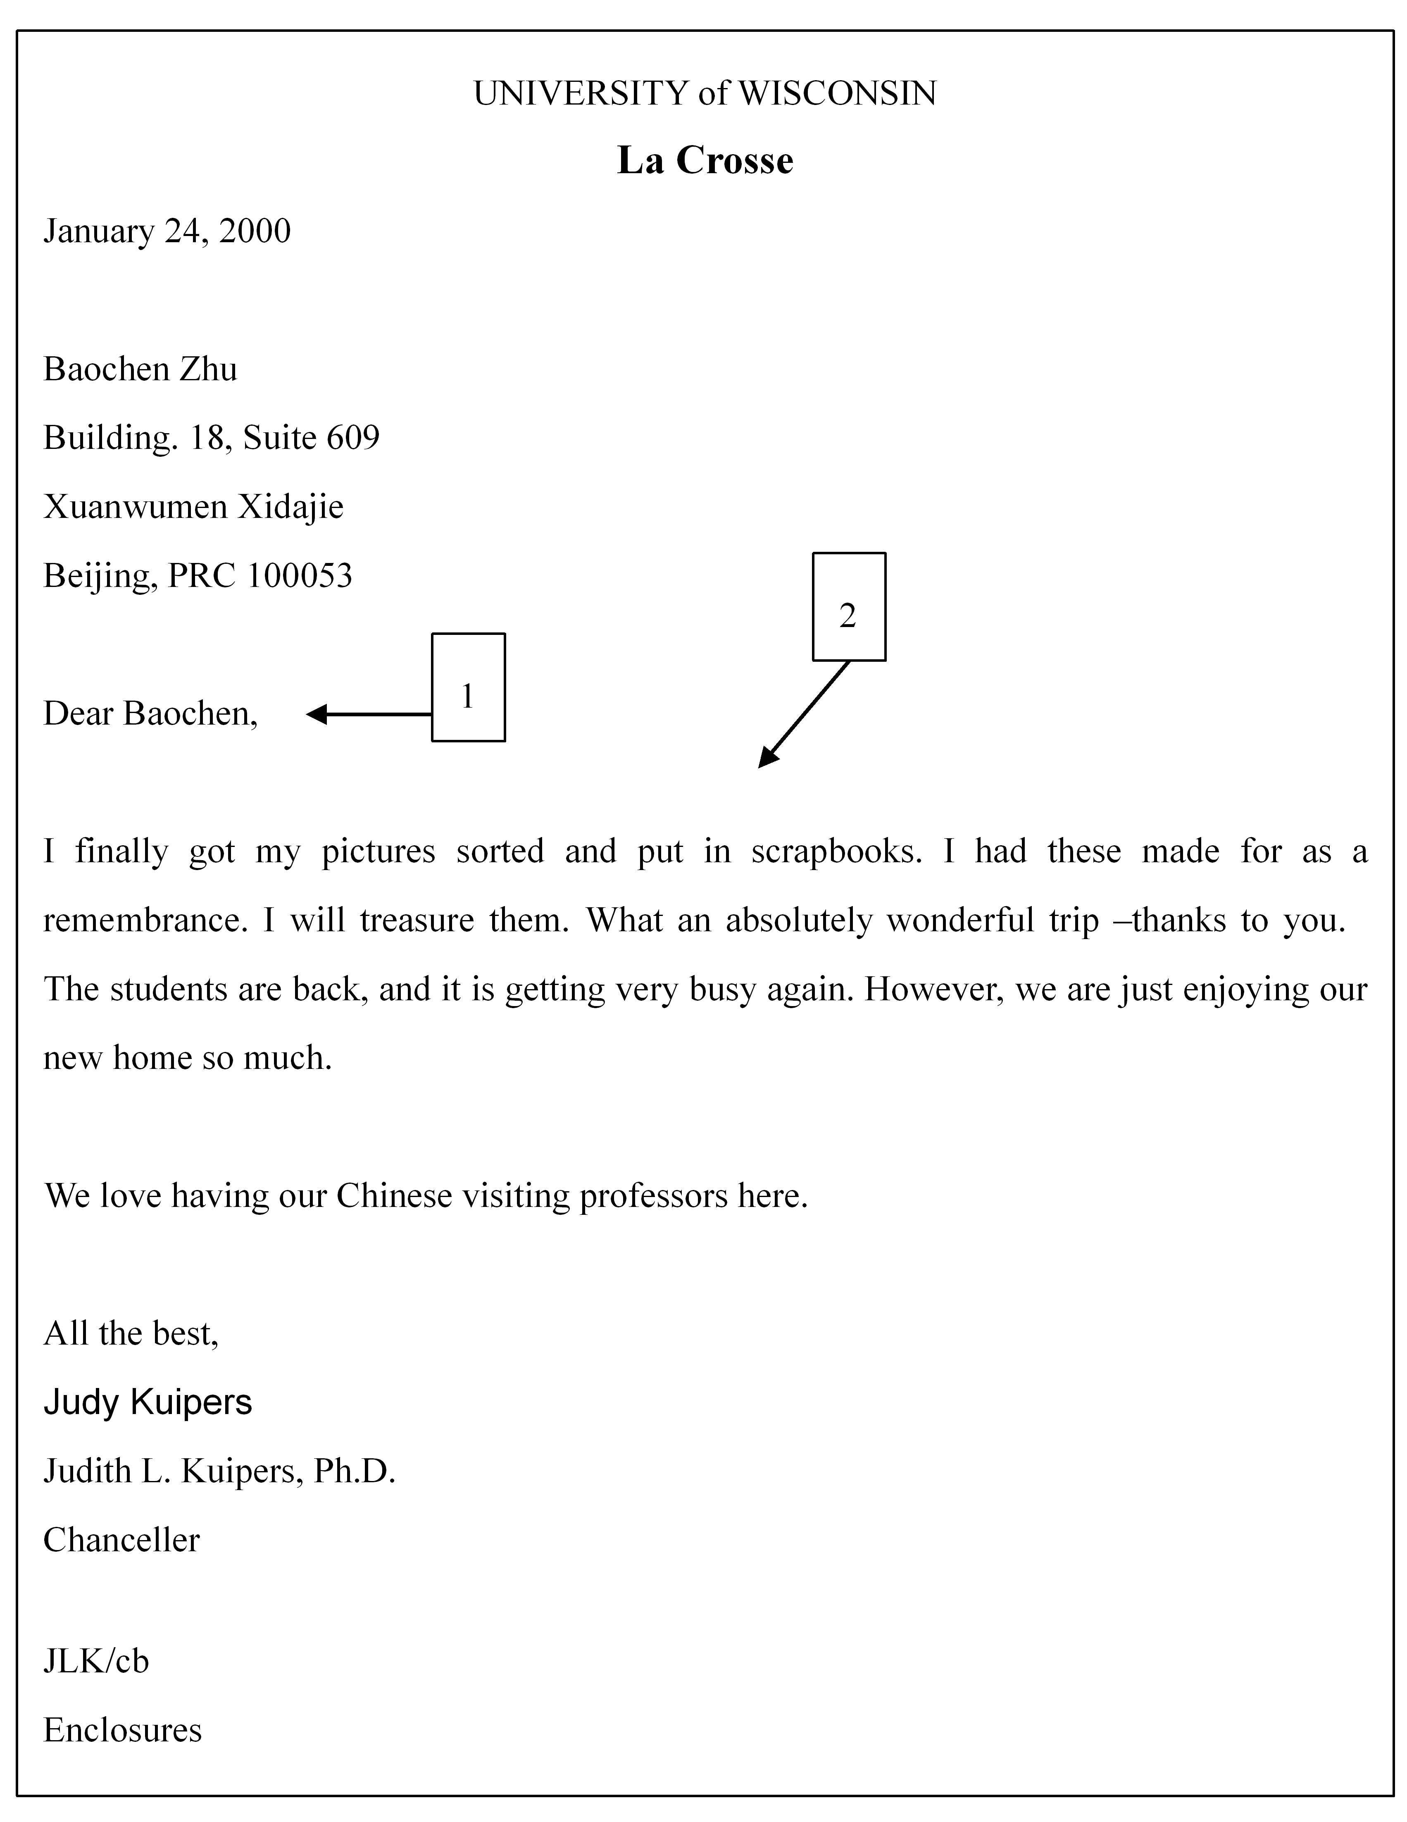
The six essential parts of a business letter include: the heading, the inside address, (PART 1) _________, (PART 2) _________ , the complimentary close and the signature.

Ⅵ. Fill in the blanks with proper words to complete the formal letter. (4%)
(Hints: Jerry Peters夫妇恭请David Smith夫妇于2009年7月4日晚上7点光临上海和平饭店共进晚餐。David Smith夫妇婉拒邀请。)
Mr. and Mrs. David Smith
1_________to accept
2_________
Mr. and Mrs. Jerry Peters
to dinner
Ⅶ. Write down the full words for the following abbreviations. (6%)
1. Jr. _________
2. Co. _________
3. ATM _________
Ⅷ. Translate the following sentences or phrases into English. (17%)
1. 你很幸运这个团还有最后一个名额。(5%)
2. 入乡随俗。(5%)
3. 中国武术是中国人民集体智慧的结晶。（5%）
4. 中国结(2%)

